roid

217, Sheikh Rashid Building

P.O Box 56272, Dubai

United Arab Emirates

Tel: +971 4 2973236

Email: uae@verbat.com

PROJECT   
PROPOSAL

**Electronic Resource Management**

|  |  |
| --- | --- |
| **Prepared for:**  **Mr. Shyam Visavadia**  Graduate Surveyors Limited  United Kingdom | **Submission Date:**  08 Mar 2018  **Proposal ID:** AD/BP/08032018/1907/1 |

________________________________________________________________________________________________________________________________  
Conﬁdentiality Notice: This Proposal is conﬁdential and contains proprietary information and intellectual property of Verbanet Technologies LLC. Neither this proposal nor any of the information contained herein may be reproduced or disclosed under any circumstances without the express written permission of Verbanet.

© 2018 by Verbanet Technologies LLC. All rights reserved. Confidential.

________________________________________________________________________________________________________________________________

Project Contacts

|  |  |
| --- | --- |
| Client Information | |
| Project Name | Electronic Resource Management |
| Client Name | Graduate Surveyors Limited |
| Client Address | United Kingdom |
| Contact Person | Mr. Shyam Visavadia |
| Contact Person Email | advice@graduatesurveyors.com |
| Contact Person Phone Number | 971 507737420 |
| Verbat Information | |
| Contact Person | Darshana S |
| Contact Person Phone Number | +971 42973236 |
| Contact Person E-Mail | [darshana.s@verbat.com](mailto:darshana.s@verbat.com) |
| Address | PO Box 56272, Dubai, United Arab Emirates |
| Physical Address | 217, Sheikh Rasheed Building, Hor Al Anz East |
| Project Information | |
| Proposed Technology/Methodology | Entity Framework, ASP.net, MSSQL, IIS, MVC |
| Anticipate Start Date | NA |
| Proposal Valid For | 30 Calendar days from the submission of the proposal |

**Table of Content**

1 Background 6

2 Scope of Work 6

2.1 Portal for Surveyors, Recruiters and Consultants 6

2.2 Specific Features 7

2.2.1 Admin Module 7

2.2.2 Candidate Module 7

2.2.3 Recruitment Module 8

2.2.4 Live Chat 8

2.2.5 Reports 8

2.2.6 Advertisements 9

2.2.7 API Configuration 9

2.2.8 Job Board Integration 9

2.2.9 Payment Gateways 9

2.2.10 Google Analytics 9

2.2.11 Membership plans 9

2.3 Proposed Solution Model 9

2.4 Solution Objective 9

2.4.1 Languages 10

2.5 Advantages of Proposed Solution 11

2.6 Why Verbat 12

2.7 Key Differentiators 13

2.8 Technology & Services 14

3 Functional Specification 15

3.1 Desktop Application 15

3.2 Mobile Application 18

4 Application Features 20

4.1 System Level Features 21

5 High Level Solution 22

5.1 High Level Architecture 22

5.2 Employer Workflow 23

5.3 Student Workflow 23

5.4 Graduate Survey Workflow 24

6 Nonfunctional Requirement (Others) 25

7 Assumptions 25

8 Out of Scope 26

9 Technology Solution 27

9.1 Proposed System Environment 27

9.2 Technical Configurations 28

9.2.1 Development Tools 28

9.2.2 Recommended Web Hosting Package 28

9.2.3 Browser Compatibility 28

9.2.4 Hardware Interface 28

10 Commercials 29

10.1 Web Application 29

10.2 Payment Terms 29

10.3 Mode of Payment 29

11 Delivery Management 30

11.1 Project Management 30

11.2 Roles and Responsibilities 30

11.3 Delivery Activity Summary 32

11.4 Project Implementation Plan 32

11.5 Deliverables 33

11.6 Estimated Delivery Time 33

11.7 Release Planning 33

11.8 Risk and Contingency Planning 33

12 Change Management 34

13 Miscellaneous 36

13.1 Acceptance Criteria 36

13.2 General Terms and Conditions 36

13.3 Assumptions and Dependencies 37

13.4 Source Code & Intellectual Property Rights 38

13.5 Maintenance & Support 38

13.6 Service Level Agreement 39

14 Our Clients 41

# Background

**Graduate Surveyors** (Here after referred to as the client) seeks the services of a specialist software vendor to retrofit the current front-end website page and build the back-end Electronic Resource Management (ERM) and collaboration system capable of assisting employers and candidates through the recruitment process. (The “Project”). The client is looking for a competent, reliable and trustworthy organization to develop the project, becoming a trusted partner of GS both during and after the project delivery and operation process.

# Scope of Work

The backbone of the application is composed of the following features

## Portal for Surveyors, Recruiters and Consultants

* A central database to house resumes in a predefined format, so that they can be portable, thus eliminating the need to store resumes in multiple formats
* An online applicant tracking system that can streamline the hiring process
* An online collaboration platform that can leverage the capabilities of Web 2.0. The platform will take advantage of both traditional and social media to source jobs and promote surveyors.
* The Applicant Tracking Software shall save time by automating the tedious task of sending interview reminder emails, generating invoices for clients and identifying leads for recruiters
* The Candidate Applicant Tracking System (CATS) shall also leverage the functionality of new media business suites from Google and Microsoft to seamlessly organize and communicate information to form a unified and organic platform
* A nimble but powerful recruitment tool that is cost-effective and frugal
* Collect multiple resumes by publishing job openings.
* A mobile ready and responsive platform that can be used by Graduate Surveyors while on the go
* A Unified platform that integrates well with Job boards and social media
* A portal that is targeted towards addressing the need of young graduates who are culturally diverse and increasingly mobile : hence the need to be extremely media savvy
* Provide lifecycle recruitment services

## Specific Features

Specifically the application shall have the following features and functionality

### Admin Module

* Admin Login
* Registration Verification
* Job Verification
* Master Data
* Notification
* Settings

### Candidate Module

* Recruiter / Candidate Login
* Sign Up / Registration
* Personal Information
* Contact Details
* Education Details
* Work Experience
* Languages
* Achievements & Activities
* Upload your Video Resume
* Employer Registration
* Process Flow
* Help
  + Email Customer Service
  + Frequently asked questions
  + How to create job listing
  + How to get more candidates
  + My current membership plan
  + Integration with Job boards? How does it work?
  + Integration with social media site? How does it work?
  + How to search employee using keyword / tag / technology / education / achievement etc.
  + CV details
* Candidate Dashboard
* Job Details
* Candidate DMS
* Candidate Forum

### Recruitment Module

* Recruiter Dashboards
* Job Creation
* Job Entry Screen
* User Profile

### Live Chat

### Reports

* Transactions Worldwide
* Top Performing Account
* Today’s Visitors
* Number of Support Questions
* Number of Employers
* Number of Candidates

### Advertisements

### API Configuration

### Job Board Integration

### Payment Gateways

### Google Analytics

### Membership plans

Verbat is pleased to submit the proposal and values it as a great opportunity to have a long term & mutually beneficial association with the client. Verbat has gone through the requirement and presents a proposal for the requested system.

## Proposed Solution Model

**Stand-Alone Fixed Bid**

Verbat will be following a stand–alone fixed bid solution delivery model wherein the required solution would be devised and a suitable pricing would be offered.

## Solution Objective

Verbat intends to build an application that addresses the overall objective of the Client’s requirement. The client has provided Verbat with a detailed requirement and Verbat shall use the provided requirements to determine the effort estimate for the project.

### Languages

* English

Detailed requirements will be covered in the section titled “Functional Specifications”

Verbat’ s Solution architects have conducted a thorough research on the requirements and have come to the conclusion that our proposed solution, which is detailed further in this document, will meet the requirements put forth by the client. And the proposed solution will be delivered in a phased approach as per Verbat’s stand-alone fixed bid solution model.

**Strong and Scalable platform:** The platform proposed will be strong and scalable enough to accommodate future enhancements.

**Accelerated solution:** The framework would act as a solution accelerator. It would provide the basic building blocks which could be reused in future for building new components and features.

**High performance:** The light weight framework used consumes fewer system resources thereby making the application perform faster.

**Security:** The application will be developed considering various aspects of security.

## Advantages of Proposed Solution



01

Agile development offering reliable, secure solution

02

Smooth transition and quicker completion of processes

03

User friendly interfaces enabling easy navigation between screens

## Why Verbat

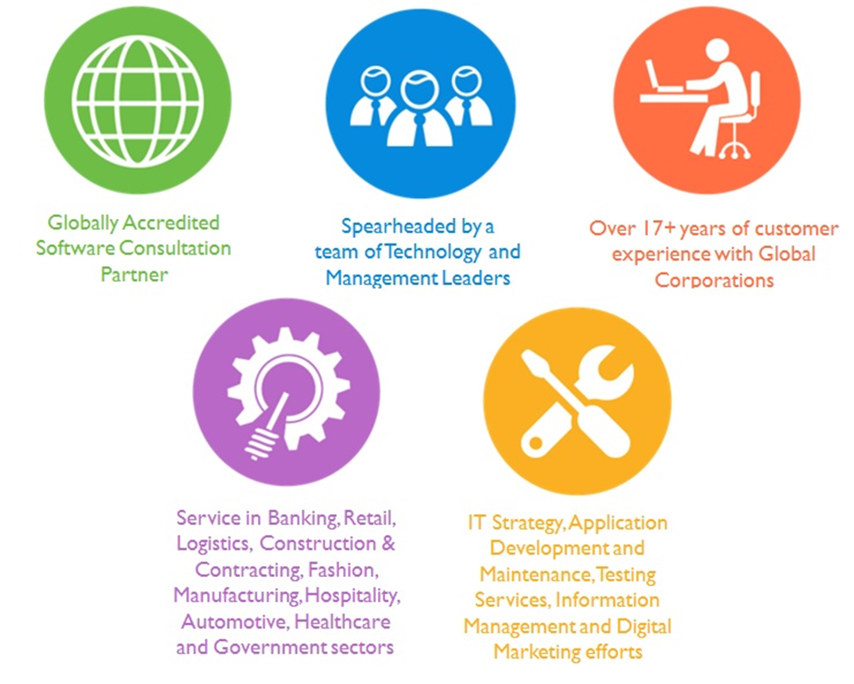

Over 18+ years of customer Experience with Global Corporations

## Key Differentiators

Delivered digital transformation expertise to global customers for over a decade by following industry best practices to maximize ROI for client

Keen technology intelligence combined with aggressive market research to deliver solutions that achieve results with measurable value

Enable access to global consulting expertise with strong local market and business knowledge

Commercial Model that is customizable for your business needs

Services that are designed to optimize applications for improved performance and overall efficiency

1,000,000 plus man-hours of expertise in technology frameworks spanning Microsoft, Open Source, mobility platforms and other proprietary IT technology

Partners top technology vendors to bring in the latest and best services in integration, collaboration, and development

Commercial Model that is customizable for your business needs

Proven Methodologies & Processes

Investment in R & D

Strong Local Presence

Flexible commercial Models

Technology Associations

Software Development Experience

Offshore Development Centre

Quality Assurance & Testing

## Technology & Services



Technology  
&  
Services

Cloud/Traditional Hosting

User Interface & Design

Digital Marketing

Mobility Solutions

Testing Services

Application  
Development

# Functional Specification

## Desktop Application

|  |
| --- |
| **Admin Login** |
| ***Login*** |
| Validate the user send email with details |
| ***Registration Verification*** |
| Search, Active, In Active, No. of Users, View user details, Activate deleted users |
| ***Job Verification*** |
| Add New, Search, Active, In Active, No. of Users, View ,Send notification) |
| ***Masters*** |
| Qualification Master |
| Category Master |
| Technology / Skills Master |
| Language Master |
| Activity & Achievement Master |
| Question |
| ***Notifications*** |
| Email |
| SMS |
| ***Settings*** |
| Email Templates |
| About Us |
| Terms & Conditions |
| ***Export Data to Excel or Other*** |
| Transfer data to Microsoft Excel or Other |
| **Candidate Module** |
| ***Candidate Login*** |
| Login, Login with Social Sites, |
| Remember Me, Forgot Password, Send Reset Email, Account Highlighted Notification |
| ***Sign Up / Registration*** |
| Registration Step 1 |
| ***Personal Information*** |
| Registration Step 2 |
| ***Contact Details*** |
| Registration Step 3 |
| ***Education Details*** |
| Registration Step 4 |
| ***Work Experience*** |
| Registration Step 5 |
| ***Languages*** |
| Registration Step 5 |
| ***Achievement and Activities*** |
| Registration Step 6 |
| ***Upload your video resume*** |
| Registration Step 7 |
| ***Confirmation Email after Registration*** |
| Registration Step 8 |
| ***Convert Candidate Profile to GS Resume*** |
| Convert Candidate Profile to GS Resume |
| ***Employer Registration*** |
| Employer Registration form |
| ***Help*** |
| Email Customer Service |
| Frequently asked questions |
| How to create job listing |
| How to get more candidates |
| My current membership plan |
| Integration with Job boards? How does it work? |
| Integration with social media site? How does it work? |
| How to search employee |
| CV details |
| ***Candidate Dashboard*** |
| Notifications, Search , Job Listing, Total View, Interview Schedules, Short Listed, Interview Declined, Export Dashboard Details |
| ***Job Details*** |
| Job Details, Send Query to Recruiter, Apply |
| ***Candidate DMS*** |
| Upload Files, Search by Tags, Preview, Delete |
| ***Candidate Forum*** |
| ***Admin*** |
| Create form Topics by Admin |
| ***Candidate*** |
| lists all form topics, displays total views, posts and subtopics |
| Detail page which displays all user post and other details |
| **Recruiter Module** |
| ***Recruiter Login*** |
| Login, Login with Social Sites (Google, Facebook, LinkedIn) |
| Remember Me, Forgot Password, Send Reset Email |
| Account Highlighted Notification |
| ***Recruiter Dashboard*** |
| Job List |
| Task & Events |
| Job Details / Activity |
| Job Details / Details |
| CV |
| Docs |
| Show Uploaded documents [based on filters (All, Documents, Audio, Video)] |
| Upload Files (DMS) |
| Search by Tags, Preview, Delete |
| ***Job Creation*** |
| Job entry details, Send notification to admin |
| ***User Profile*** |
| My Profile |
| My Settings & Preferences |
| My Templates |
| Users (Manage license user account) |
| Purchase (Licenses, Payment) |
| **Other Functions** |
| Live Chat |
| ***Reports (With Export Functionality)*** |
| Transactions Worldwide |
| Top Performing Account |
| Today’s Visitors |
| Number of Support Questions |
| Number of Employers |
| Number of Candidates |
| New Registrations |
| Advertisement (Management, Subscription, payments, dashboard, placeholder management) |
| API Configuration |
| Job Board Integration (per site) |
| Payment Gateways (PayPal, Sage, Allied Wallet, World Pay) with accounting, tax &entity registration |
| Google Analytics |
| Membership Plan Details |

# Application Features

## System Level Features

* Authentication and Authorization: The system will validate the identity of the user and then authorize the user and assign a specific role that they have been mapped to by the admin
* Auditing and Logging: The system will log the activity of the logged in user so that it can be tracked for security purposes. The system will also log the actions being performed by the system so that it can identify issues caused by systemic application failures
* Scheduled Jobs: The system will have scheduled jobs running at specific intervals to aid in the application workflows
* Exception Handling: As a part of managing user expectations, exceptions or inadvertent application failures will be handled by providing user friendly and contextual error messages. All exceptions will be logged for future reference so that it can be handled better.
* Security: Security of the site is managed through a combination of the logs maintained by the system as well as additional functions such as
  + Secure communication using SSL (If requested)
  + Password salting
  + Provision to secure the site against Cross Site Scripting attacks (and reflected XSS), SQL Injection attacks, Code Injection, buffer overflow vulnerability

# High Level Solution

## High Level Architecture

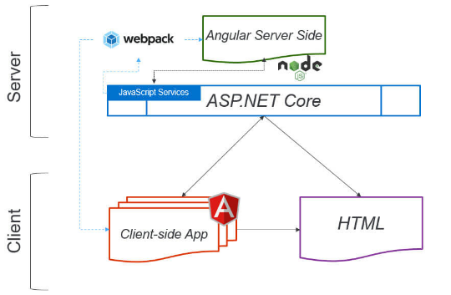

## Employer Workflow

## Student Workflow

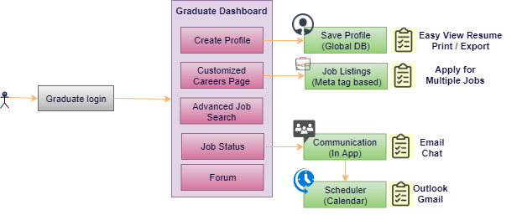

## Graduate Survey Workflow

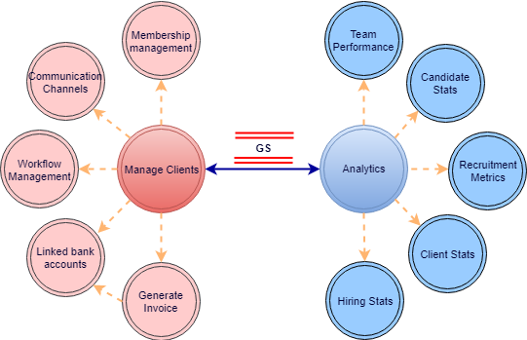

# Nonfunctional Requirement (Others)

|  |  |
| --- | --- |
| **Requirement** | **Details** |
| User Experience and  UI Design | * The application will be developed only in English * The layout and graphical components will be created considering the usability factors |
| Performance | * Application will allow users to have smooth and quick access to the information or services they require. |
| Security | * The system will be protected against attempts of security breaching that may arise. * Web security standards will be followed. |

# Assumptions

The project solution and technology is created from the initial understanding of the requirement shared with Verbat through mails and meetings. The proposed solution is based on the following assumptions:

* Client to provide Verbat with the branding guidelines.
* The proposed application front end and backend would be in English
* Client will purchase the necessary templates needed for development
* Client shall provide licensed images and logos in specified size & format
* Super Admin can manage all the users within the application.
* Requirements should be well defined, agreed and signed-off by the client
* Internet connectivity is required for the functioning of the web application.
* UI development effort is 4-8 hrs. per screen for all screens not covered in the proposal
* Reporting and analytics may require external tools. Current assumption is that analytics will be minimal and simple.
* Testing will be done in latest versions of Google Chrome, Mozilla Firefox & IE web browsers only
* Development Contingent upon timely feedback from client
* Recommended Chat Plugins to be provided by client

# Out of Scope

With the ever evolving digital market, the requirement needs should be clear to both the parties involved, hence the importance of mentioning the out of scope details of the project. Following are considered to be out of scope while creating this proposal.

* Purchase of images, fonts
* Adding new features to the application other than mentioned in the functional specification.
* Any language other than English
* Manual data entry
* Hardware Integrations / procurement and purchase
* Database migration
* Content writing
* Content or image procurement or uploading or editing.
* Hosting Infrastructure and Maintenance
* Annual Maintenance of the application (Bug fixing, debugging) - For AMC details, please refer section titled “Maintenance and Support”
* Physical deployment at client’s site
* Backup solution and Disaster recovery

# Technology Solution

## Proposed System Environment

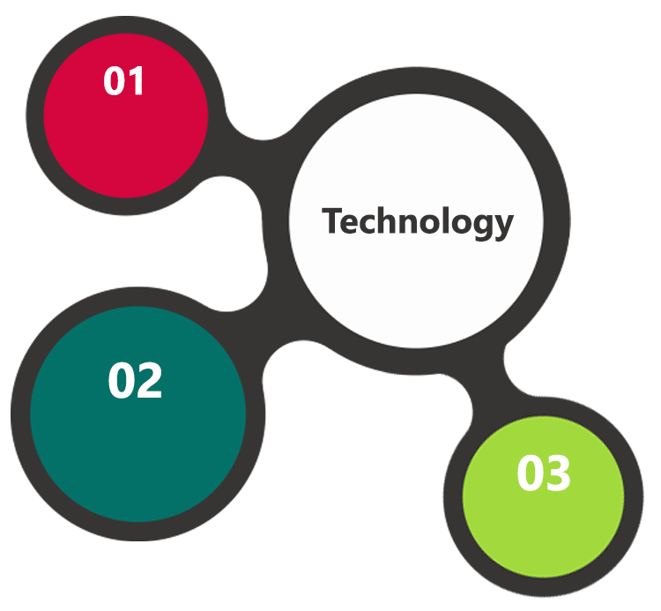

HTML / CSS3 /

JQuery

IIS..Net 4.5  
MSSQL

MVC/C#/Angular

**MS SQL2012  
Windows 8/10  
Web Services**

## Technical Configurations

### Development Tools

* Visual Studio, MVC, c#, Angular
* MSSQL
* HTML / CSS 3
* Ajax, JavaScript, JQuery

### Recommended Web Hosting Package

* CPU: 4 cores
* RAM: 12 GB
* Disk Space: 200 GB
* Data Transfer: 200 GB
* OS Windows server 2012
* Database: MSSQL
* Web site Server Software – IIS 8.0

### Browser Compatibility

* Chrome version: 56
* Firefox version: 51
* Edge version: 39

### Hardware Interface

**Desktop**

The application is reliant on hardware interfaces to provide a seamless automated user experience.

* Computer with Windows 8 or 10 OS
* Compatible Browsers as specified in section 9.2.3

# Commercials

## Web Application

|  |  |  |
| --- | --- | --- |
| **No** | **Description** | **Amount (USD)** |
| 01. | Responsive Web application | 00,000.00 |
| 02. |  | 00,000.00 |
|  |  |  |

*Note:*

* *The above cost does not include Application hosting, integration, Project Management or deployment*
* *Request for customization will be considered as change request and shall be chargeable*
* *The above cost is exclusive of VAT applicable in UAE*
* *The above cost is based on the initial understanding of the requirement grounded on the details shared by client. Any further changes in the scope or complexity if encountered during detailed system study/ analysis will call in for additional effort and time*
* *For feature additions, please refer section titled “Change Management “*

## Payment Terms

* 50% of the total project value to be paid as advance along with the purchase order
* 50% of the total project value to be paid on application development and UAT Signoff on Verbat Server

*Note: Payment should be made within 7 days from the date of the invoice*

## Mode of Payment

By Cheque to Verbanet Technologies LLC

OR

Wire transfer to our bank account

Bank Name : Emirates NBD

Account Name : Verbanet Technologies LLC

Account Number : 1011492858201

IBAN Number : AE61 0260 0010 1149 2858 201

Swift Code : EBILAEAD

Bank Address : Mamzar Branch, Dubai

*Note:*

* *Bank charges incurred during wire transfer to be borne by the client.*
* *Any local taxes / VAT applicable to be borne by the client*
* *Client invoices will include VAT charges in addition to the application cost*
* *LPO to be raised in the name of Verbanet Technologies LLC for project initiation*

# Delivery Management

## Project Management

The Verbat development center strictly follows industry standards on quality. The project management is process governed by the Verbat Quality Management system and is put to verification through internal audit programs that happen from time to time.

Verbat will dedicate a project manager for the proposed implementation. Verbat proposes Client to identify one project manager who will be driving activities to be undertaken by Client to be the single point of contact for Verbat.

## Roles and Responsibilities

Verbat will assign a dedicated Project Manager/Project Lead to lead the project, who will be the first point contact for Client. He/she will be responsible for planning and managing the various activities within the project. He/she will work closely with Client Project Manager, to give periodic status updates and ensure high level of visibility and comfort on the progress of the project.

The Project Manager/Project Lead will lead the co-ordination between Verbat and Client, thus enabling smooth transitioning of Client requirements to the Verbat’s offshore delivery team, and provide visibility as well as comfort on the progress of the services to Client.

He/she will have periodic meetings with Verbat’s Senior Management, thus ensuring Verbat’s Management commitment and focus on Client initiatives.

## Delivery Activity Summary

|  |  |
| --- | --- |
| Activities | Description |
| Detailed requirement Analysis | Verbat team to conduct detailed study of requirement for the phase. If clarification is required, team will reach out to Client for more information and/or time for discussions. |
| DB Design | DB design for central and test DB. |
| Software Requirement Specification document (SRS) | Once the requirement analysis is completed, Verbat team will submit the SRS document for approval |
| UI/UX Design, Prototyping | Based on the SRS, Verbat UX/UI team will work on the UI/UX of the screens and submit a prototype for approval |
| Functional Specification Document (FS) | Once the Prototype. UI/UX is approved, Verbat shall submit an FS document for approval. |
| Development | Actual system development starts based on the FS. This involves detailed design and software development of Web Application. |
| Testing | Test Planning, test plan creations, internal, integration testing and user acceptance testing. |
| Deployment | Deploying the latest built in the Verbat Test Server. |

## Project Implementation Plan

Verbat will be providing the solution in a stand-alone fixed bid approach which ensures minimum viable solution for quick wins with core focus on the long-term business objective and outcome. Once the implementation is over, Verbat will initiate the application maintenance process (once the maintenance contract is signed) which continues to extend after the implementation.

## Deliverables

* Scope Document
* Project Plan
* SRS
* Prototype of the application
* Test Plan Document
* Source Code
* Fully Developed & Tested Application

## Estimated Delivery Time

The effort estimated for delivering the application will be as below:

**UAE working days for prototype from the date of Approval of the project (LPO/Signed proposal) with advance payment: 20 working man days**

**UAE Working days for the development of the application from the Date of Approval of the Prototype: 5.5 working man months**

|  |  |  |  |  |  |  |  |  |  |  |  |  |
| --- | --- | --- | --- | --- | --- | --- | --- | --- | --- | --- | --- | --- |
|  | **Month 1** | | **Month 2** | | **Month 3** | | **Month 4** | | **Month 5** | | **Month 6** | |
| **Activity (10 Day Increments)** | 10 | 20 | 30 | 40 | 50 | 60 | 70 | 80 | 90 | 100 | 110 | 120 |
| Designing & Prototyping | 19 | |  |  |  |  |  |  |  |  |  |  |
| Web Site |  | 10 | |  |  |  |  |  |  |  |  |  |
| Admin + Application framework |  |  | 16 | |  |  |  |  |  |  |  |  |
| Candidate + Recruiter module |  |  |  | 35 | | | |  |  |  |  |  |
| Forums |  |  |  |  |  |  | 6 |  |  |  |  |  |
| Reports + Chat |  |  |  |  |  |  | 8 |  |  |  |  |  |
| Advertisement Management |  |  |  |  |  |  |  | 5 |  |  |  |  |
| API Management |  |  |  |  |  |  |  | 5 |  |  |  |  |
| Job Board Integration |  |  |  |  |  |  |  |  | 1.5 |  |  |  |
| Payment Gateway integration |  |  |  |  |  |  |  |  | 10 |  |  |  |
| Membership plans |  |  |  |  |  |  |  |  |  | 5 |  |  |
| QA UAT Deployment |  |  | **22** | | | | | | | | |  |

|  |  |
| --- | --- |
| **Activity** | Days |
| Designing and Prototyping | 20 |
| Web Site | 25 |
| Admin + Application framework | 33.125 |
| Candidate + Recruiter module | 69 |
| Reports + Chat | 73 |
| Advertisement Management | 78 |
| API Management | 80.5 |
| Job Board Integration | 82 |
| Payment Gateway integration | 86.5 |
| Membership plans + Google Analytics | 90.25 |
| QA | 111.25 |

*Note:*

* *The above-mentioned timeline is in UAE Working Days*
* *The initiation of the development is dependent on the confirmation of design. Design will be submitted post the confirmation of the project along with LPO, signed proposal and advance payment*
* *Project plan will be submitted post the confirmation of project with necessary payments*
* *Any delay in getting the approvals of deliverables from client will cause change in timelines and the revised timelines will be updated in weekly status reports shared with client after the project commencement*
* *All approvals and queries regarding the client requirement and any queries which may hinder the project advancement at any stage should be answered by the client within 24 hours from the time of initiation, failing which the time delay will get added to the actual effort and timeline which was estimated.*

## Release Planning

* Client will be informed about the release date and time through email.
* Client performs the UAT

## Risk and Contingency Planning

Verbat has identified various risk factors associated with this assignment and understands the impact of these risk factors on the project schedules. The objective of this section is to highlight for both Verbat and client, the risk factors, to analyze the impact of the risks on project execution, and to propose strategies to control and reduce the impact of the risk factor.

These various risks, which could arise during the project, are tabulated below along with mitigation implementation.

| Type of risk | Impact | Risk Mitigation | Risk Handling |
| --- | --- | --- | --- |
| Scope Creep | H | Functions and features will be detailed in system requirement documents and will go through client approval. Once this document is approved, any change to requirement will go through change management review for possible impact assessment. | Proper change management procedure will be implemented. |
| Delay in customer feedback | H | The plan is prepared with enough lead-time for customer reviews and approvals.  The customer is indicated with the dates when the document is expected after review and approval. | The request for feedback will be escalated if not attended at the right time so that the schedules are not affected. Deemed acceptance criterion is set up front and will be followed. |
| Non-availability of necessary software’s, frameworks, database instances and infrastructure at client’s hosting environment(If hosting support is provided by Verbat) | M | Client will be informed in advance on these requirements. | Possible impact to schedule. |
| Manpower attrition | L | All efforts would be made to ensure process dependence rather than being person dependent. As a risk mitigation plan Verbat will train backups. | A new person will be identified as early as possible, provided the required project-specific training and mentored by the senior members of the team to minimise impact of attrition on the project. |

*H-High, M-Medium, L-Low, NA-Not Applicable*

# Change Management

Any addition which comes out of the project scope, upon and after the launch of the tool will be considered as change management. Verbat recommends the following change management procedure for the same.

* Any change which comes out of the project scope, which was discussed, documented, and mutually approved by both the parties in the requirement stage, will be carried out only through raising a change request.
* Change request will be studied and an impact analysis on the existing work flow will be performed.
* On finalizing the impact, effort estimation for the change will be calculated and raised as additional requirement.
* Verbat will initiate the change request only after getting a formal approval from the client for the additional changes raised.
* Any change from the scope will be charged at **USD ----- per man day effort** and approval from the clients will be availed before commencing on any change management.

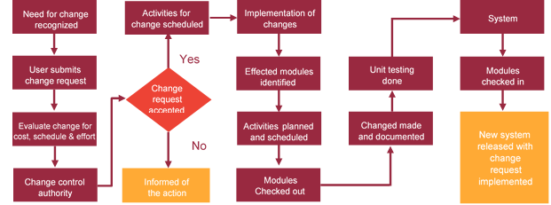

# Miscellaneous

## Acceptance Criteria

* UAT sign off should happen within 7 Days from the release of the application/ Phase and the acceptance confirmation needs to be mailed to Verbat failing which Verbat will consider the project as approved by the client.
* Any comments or reason for rejection need to be documented and the same needs to be sent as an email from the official mail id of client to Verbat.

## General Terms and Conditions

* An average of 20 working days are assumed in a month
* All the projects activities will be carried out from our off-shore development center in India
* The scope of the project is to develop the Application as detailed in the scope of the project and mentioned in this proposal. Any changes or additions will have to go through change management.
* This proposal and all technical/ functional specifications have been derived or concluded from the data shared via email / information's transferred during the initial requirement analysis meetings and conversations. Verbat reserves the right to amend the terms of this proposal, should the SOW terms, functional features and functionalities change during the course of the project
* Application will be best viewed only in the environment mentioned in the section 7.2.3
* All the documentation will be provided in English.
* Third party components may be used to develop this application.
* All Source Code and other project artefacts would adhere to the Verbat document templates and internal coding standards
* Acceptance criteria shall be based on the clauses which were mutually discussed between Verbat and client at the Requirement Analysis phase and the same will be documented and approved by both parties through official emails
* In case Client requires any extension of the proposed acceptance schedule, the associated effort and cost of such extension can be mutually reviewed.
* For any circumstances if project needs to be put on Hold / Stop it requires minimum request notice period of 1 week along with duration for which request will be addressed by management and final decision on the request will be based on that
* If deployment is done in client’s server, Verbat cannot be held responsible for any performance issues arising due to hardware malfunctions.
* Client is responsible for data backup in case the application is not hosted on Verbat server.
* Source code will only be delivered or uploaded on the Production Server once the due payments are made.

## Assumptions and Dependencies

* Detailed system study is required before the start of the project.
* During the requirement gathering phase, authorized personnel from the Client’s side is expected to be available for discussion and finalizing the HLD (High Level Design), before development commences.
* Type of reports and formats, if under the scope of the project, needs to be specified by Client before project sign off.
* Workflows if under the scope of the project, need to be specified/ confirmed by client before project signoff.
* All queries regarding the client requirement and any queries which may hinder the project advancement at any stage should be answered by the client within 24 hours from the time of initiation, failing which the time delay will get added to the actual effort which was estimated.
* Verbat assumes that all sign-offs from Client will be provided within agreed and specified timeframe.
* Client will provide all the necessary contents, both text and image, before starting the project in the format suggested by Verbat (if any).
* The client should provide the relevant information and data well in time for the execution of a related activity. Non- availability of this information or data may lead to an interruption of work which may result in a delay in delivery as well as additional costs to the client.
* Client should have/possess server with technical specifications as suggested by Verbat for the proposed application.

## Source Code & Intellectual Property Rights

* Upon completion of the Project and 100% completion of the payment, client will have access to the source code except for propriety codes, developer tools and third party application etc.
* The solution offered will be the intellectual property of the client and will be made available to the client on an “unlimited license” basis.
* Modifications by third party/person: No person or organization, other than Verbat or any person authorized by Verbat in writing, has any permission to modify/change the software Solution to be eligible to get continued support from Verbat as per the support terms defined under this document.
* Liabilities/Damages: Verbat accepts no liability or damages of any kind arising out of use or non-use of the software delivered. The responsibility of testing of software lies with Client.

## Maintenance & Support

* Maintenance contracts by default are supported as per the basic SLA terms.
* **AMC with Basic SLA is charged at 20 % of the total project value**. Additional Effort/change management request will be added towards Total Value of the Project to determine the AMC value.
* Maintenance support is limited to providing application support for ensuring the consistency of the look-and-feel, bug fixes and user issues i.e. maintenance and support of the existing features of the application.
* Support does not in any way cover providing technical or other support to the end users. The maintenance agreement does not include functionality changes or feature additions which are handled as change requests which will be charged AED 1200 per man day. AMC does not include server support, maintenance and application deployment.
* AMC charges will cover Off-Site Support and Debugging. Support includes E-mail, Telephone and Chat unless explicitly specified. In the event, the application is hosted with the client; necessary remote desktop connectivity should be provided for carrying out maintenance activity.
* Gap in AMC - In case if the client does not opt an AMC for a year and want to renew it after that period, 50% of the AMC amount for the year for which AMC is not taken will also be payable if the client wishes to renew the AMC contract.
* Note:
  + Please note that the AMC support shall start only after all the necessary sign-offs (AMC Document) to this effect have been given.
  + It is not mandatory that the client should opt for an AMC. The client will still be supported on an ad-hoc basis on an agreed man-day rate.
  + AMC Payment Terms: 100% to be paid as advance.

## Service Level Agreement

|  |  |  |  |  |
| --- | --- | --- | --- | --- |
| **Key** | **Max Response Time** | | **Max Resolution Time** | **Target** |
| Basic | 1  working day | 3 working days | | Request / incident / problem tickets |
| Advanced | 5 Business Hours | 12 Business Hours | | Request / incident / problem tickets |
| Priority | 3 Business Hours | 5 Business Hours | | Request / incident / problem tickets |

Note:-

* We provide Basic SLA as standard with AMC while Advanced and Priority SLAs attract additional charges.
* Time zone applicable as per India time zones (3:30 AM GMT to 12:30 PM GMT- Monday to Friday).

# Our Clients

**UAE University**

Education

Transportation

**Canada Cartage**

Construction

Services

Finance

We look forward to hearing from you soon and hope that you will give us the privilege to work with you in meeting your business goals. Thank you.

Thank You



©   
1999 - 2018. All Rights Reserved   
Verbanet Technologies LLC  
www.verbat.com